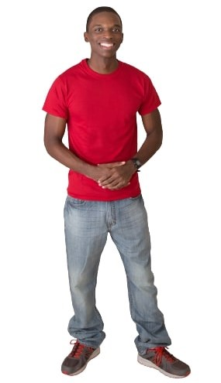

|  |  |  |  |
| --- | --- | --- | --- |
| hand | foot | head | knee |
| hair | shoulder | nose | arm |
| leg | fingers | eye | ear |
| teeth | toes |  |  |